**Software Requirements**

The project is located at: <http://automationpractice.com/index.php>

1. Introduction

1.1. Purpose

The purpose of this document is to present a detailed description of Online Web Store application (hereinafter called Online Store, Store or simply Project). It will explain some of the key features at very high level.

1.2. Scope

The document will cover the basic functionality on high level regarding the Online Store. The

user-management system, the Orders creation and operation and its respective details (hereinafter called Pictures). The administrative part – what the special user (hereinafter called Administrator or Admin) can and cannot do as well as the normal user.

2.0.Overall description

2.1. System environment

The Store has two active actors and one cooperating system. All of them are accessing their parts from the internet. The Unregistered user can access the basic functionality of the project. One can view clothes, categories and pictures. The Registered user can access some of the basic CRUD operations over the orders. One can create order, edit its own orders, add and remove details from it, filter products and write product comments.

2.2. Vocabulary

2.2.1. **Product page** – A product page is the main information block regarding a product. It consists of the Product Name in the right side. The category it’s created in. Share and Add to cart buttons. And a cover image on the very right side. Form for leaving product review comments (should be sent for approval by the store Moderator).



2.2.2. **Simple view** – A simple view is the main short information block regarding a product. It

consists of the Product name in the middle (should contain Product name and price in USD). The picture itself under it. A description under it, if any. Available colors and information is it in Stock. Under it, on mouseover, the view should display “More”, “Add to wishlist” and “Add to compare” buttons.

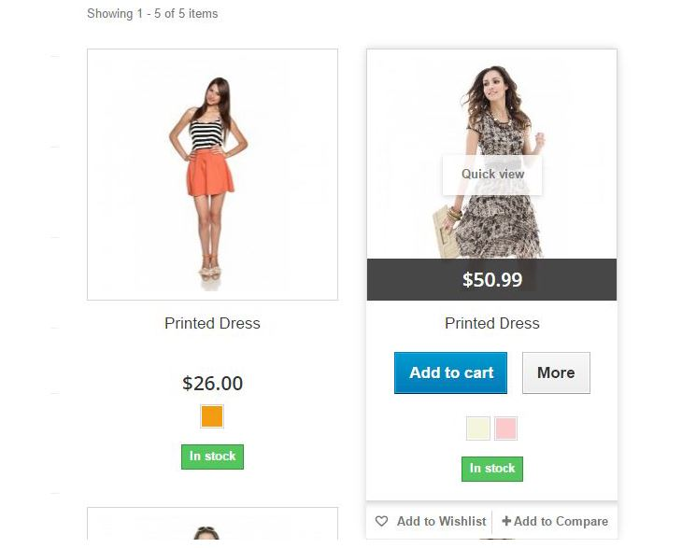

2.2.3. **Quick view** – Quick view is short information regarding particular product. In the header is placed Product name and Condition details, alongside with short description. Below this block, Share buttons should be placed. At the right block a Product price in USD, Quantity,

Size, Color of the Product should be shown. Under those, “Add to cart”and “Add to Wishlist” buttons. This block contains all product pictures in an album (in a grid with pictures in row). Each picture is a thumbnail and a hyperlink leading to the corresponding Product page.

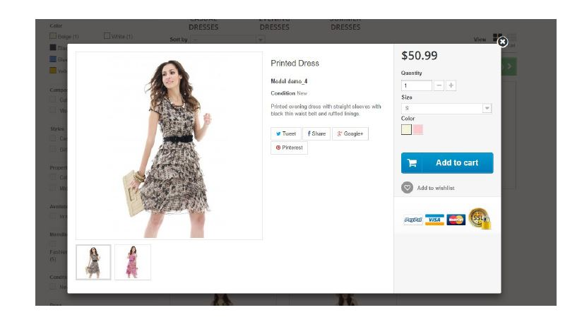

**2.3. Functional requirement specification**

2.3.1. Use Case 1 (Accessing the system)

The system is accessed through the internet from its initial URL. It loads header, navigation bar and a home page

2.3.2. Use Case 2 (Navigation bar)

The navigation bar has navigational hyperlinks to the Contact us and to the Sign in. As well as it should have navigation to the Product categories, Search and Cart.

2.3.2.1.1. Navigation bar – user management

When the visitor is unregistered, hyperlink navigating to the Sign in and Register page should be present. When the visitor is registered hyperlinks to the My account page and to Logout page should be present instead. When user is successfully logged out, there should be a redirect to the Sign in and Register page.

2.3.3. Use Case 3 (Home page)

The home page shows the Product blocks ordered by popularity rating and a header “Sale off” marketing section. Clicking on the Slider’s Arrow buttons on an album leads to the Next/Previous slide.

2.3.4. Use Case 4 (Products Category Page)

Information regarding the Main Category name (e.g. Women) is shown and a sub-category links (e.g. Tops, Dresses) where user can choose where to go next. Filter functionality offers the possibility to limit what products are shown, based on:

1. Categories

2. Price

3. Color

4. Compositions

5. Styles

6. Properties

7. Availability

8. Manufacturer

9. Condition

10. Size

The respective information regarding the products is shown on the page in a form of returned results by the given criteria. When the filter conditions and criteria are valid, the page should display the respective products found. If the input data is invalid, a respective error box is shown, indicating that “There are no products.”

Comparison of products should be possible only when user has selected at least two products (but no more than three) and had Added those by clicking on each product’s “Add to Compare” button.

Sorting of the products should be available on:

1. Price: Lowest first

2. Price: Highest first

3. Product Name: A to Z

4. Product Name: Z to A

5. In stock

6. Reference: Lowest first

7. Reference: Highest first

8. Sale off: Highest %

2.3.5. Use Case 5 (Product Comparison Page)

Information regarding the added for comparison products is shown and share this with friends, box where user can compare the particular products. We only support the following comparisons criteria:

* Compositions
* Properties
* Styles

2.3.6. Use Case 6 (Add product to cart)

In order to add product to cart, one needs to login to the site. By clicking “Add to cart” from any product view, the user is navigated to a Place an Order/Proceed to checkout page and prompted to follow 5 steps process in order to finish the process. First stage of the flow is “Summary” section, where user can check the Product information again and select Quantity. Total price (product, shipping, tax) is shown here. Clicking on “Proceed to checkout” button validates all the fields. If everything is validated, the user is taken to the next “Sign in” section, in case user is already logged in, the Order form should skip this section and move the user to the “Address” section. Here user can select from the provided by him/her addresses. Information about two addresses should be shown here: Delivery and Billing. Both can be updated. Next section is “Shipping”, where we provide the user with our supported service provider options. This screen should inform what is the current fee by each provider. It is required to get user agreement about terms of service, before proceeding to the final “Payment” section. On this screen we again provide short product description and payment options. When Payment option is selected, user is taken to the “Confirm order” screen. When user confirms order, we should inform him/her that the order is complete. User can cancel order at any section by clicking “Continue Shopping” arrow link.

2.3.7. Use Case 7 (Categories list)

Clicking on the Categories hyperlink from the header navigates to the categories page. For any regular user, a category name and the relevant products are shown. Each category is hyperlink, leading to category view, where all product blocks in that category are shown.

2.3.8. Use Case 8 (My account)

Clicking on the Username hyperlink from the header navigates to the My account page. Page lists a collection of all available sections:

* Order history and details
* My credit slips
* My addresses
* My personal information
* My wishlists

2.3.9. Use Case 9 (Search)

Clicking on Search from in the header allows for product finds by given keywords. If we have such products, we should show a list with the results. If no product is found, we should display error message stating that “No results were found for your search {"keyword/s"}”